Your submission for this activity should be a Word document that includes the following screenshots, each labeled for the step that the screenshot represents:

1. Provide a screenshot to show that you have no *containers* running on your Docker Desktop.

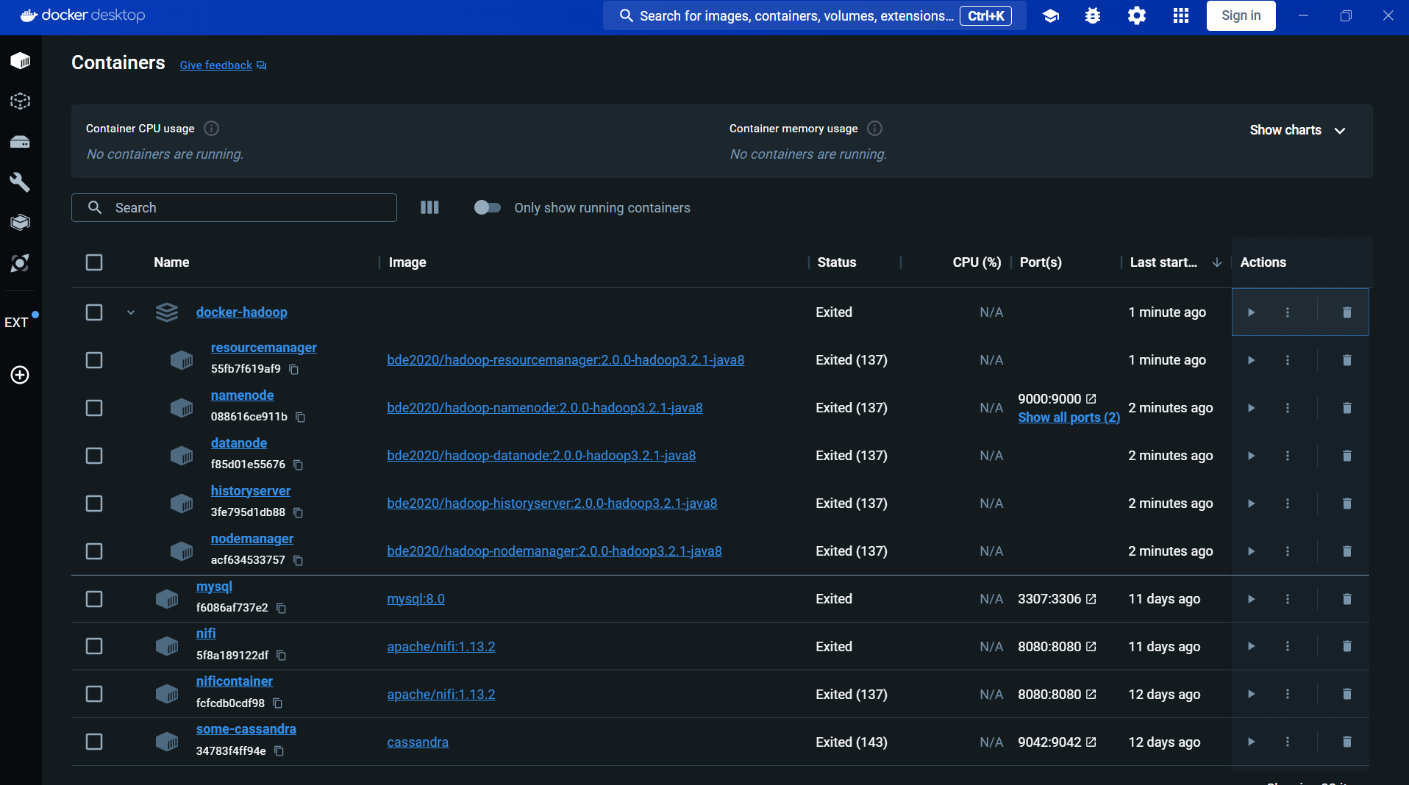

1. Provide a screenshot to show that you successfully created the bitnami folder.

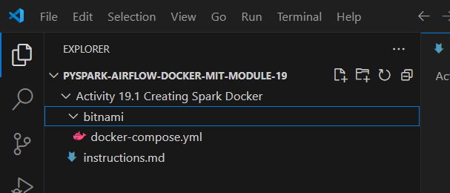

1. Provide a screenshot to show that you successfully ran the curl command to download the docker-compose.yml file.

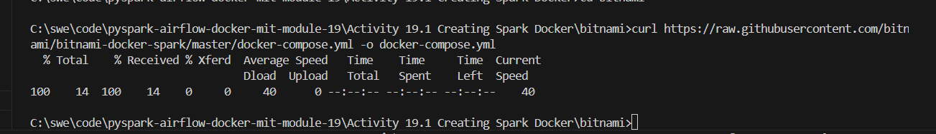

1. Provide a screenshot to show the contents of the Spark folder within the docker-compose.yaml file.

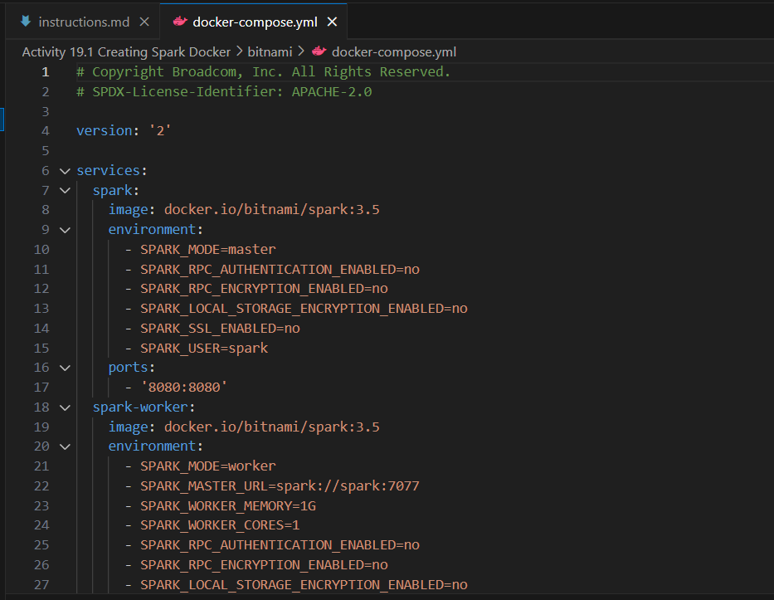

1. Provide a screenshot to show that you successfully ran the docker-compose command.

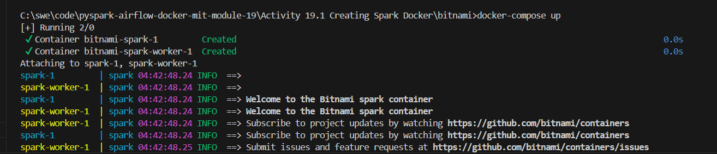

1. Provide a screenshot of your Docker desktop to show that the Spark Docker *containers* are running.

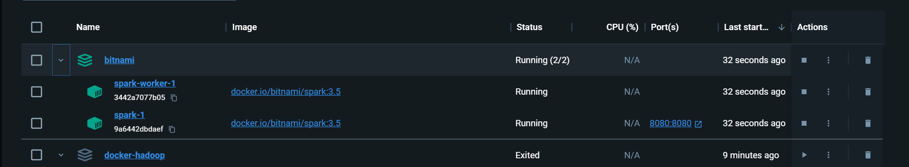

1. Provide a screenshot to show that you successfully opened your browser to the Spark webpage.

